Tasking Manager User Profile to Field Mapper Tasking Manager
Object Sequence Diagram
The two end points represented in this scenario can be any two projects utilizing the TM-Admin framework.

@startuml
Participant “Tasking Manager” as TM
Participant “Field Mapper Tasking Manager” as FTM
TM -> FTM: ShareUserProfile(OSM username, supported_user_attributes)
activate FTM
alt “username exists”
FTM -> FTM: Update user information
note right: how will it merge\nif both sides have\nbeen changed?
else “username does not exist”
FTM -> FTM: Create new user
end
alt “Success”
TM <- FTM: SUCCESS
else “Failure”
TM <- FTM: FAILURE, Error Code, Error Msg
deactivate FTM
end

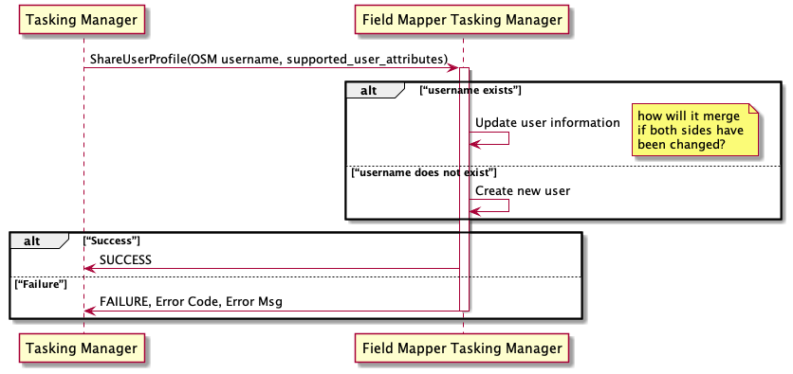
@enduml

